Atomic Energy Education Society
Class:-6 Sub:Mathematics
Worksheet-1

Q.1. Which of these figures are symmetrical?
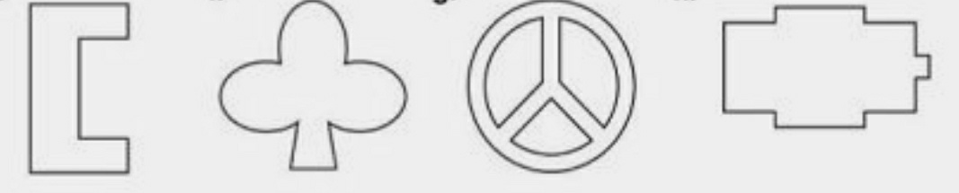

Q.2. Draw lines of symmetry for the following figures.

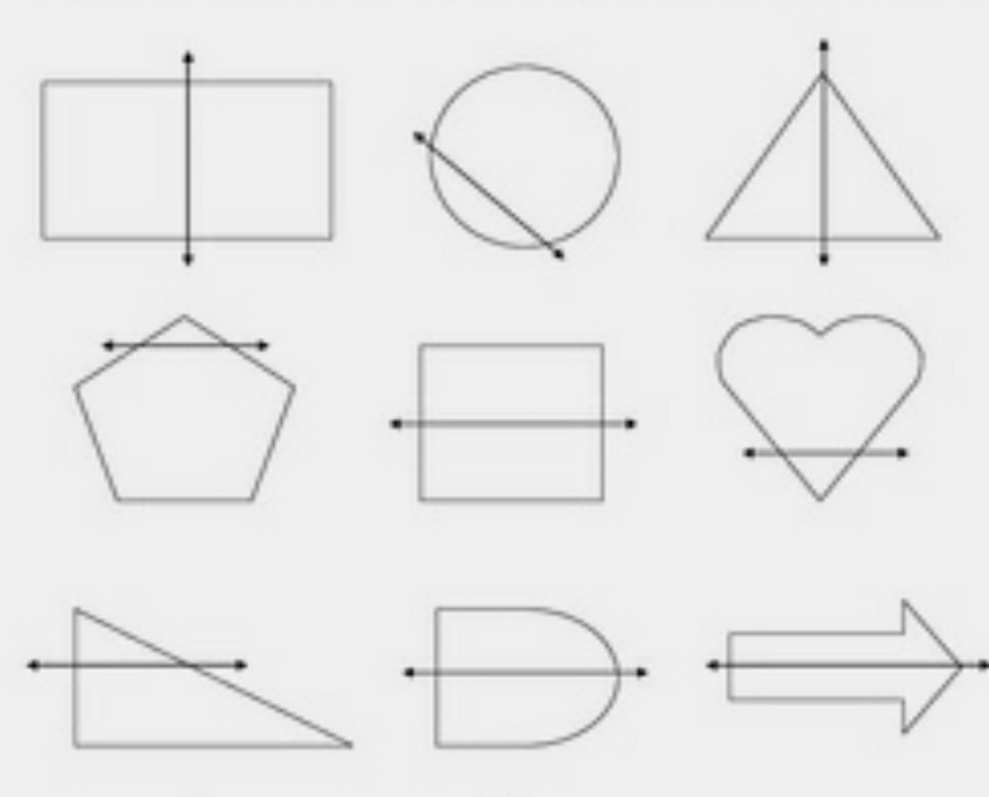

Q.3. Draw the symmetric halves to complete the figures.

