Atomic Energy Education Society – Distance Learning Programme
Class – VI Subject – Mathematics
Chapter – 9: DATA HANDLING

Worksheet -2 (Module 2/3)

- Fill in the blanks :
- A _______ represents data through pictures of objects .
- In a pictograph, if a symbol ∆ represents 20 apples in a basket then ∆ ∆ ∆ stands for ________ apples.
Do as directed:
- The following table gives information about the circulation of newspapers (dailies) in a town in five languages :

Language | English | Hindi | Tamil | Punjabi | Marathi
Number of newspapers | 5000 | 8500 | 500 | 2500 | 800

Prepare a pictograph of the above data, using a symbol of your choice, each representing 1000 newspapers.

- The number of scouts in a school is depicted by the following pictograph:

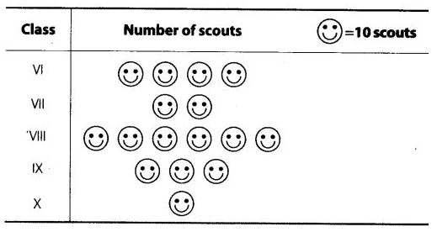

Observe the pictograph and answer the following questions:
(a) Which class has the minimum number of scouts?
(b) Which class has the maximum number of scouts?
(c) How many scouts are there in Class VI?

^*^*^*^*^*^*^*^*^*^*

