TRANSPORTATION IN ANIMALS AND PLANTS
MODULE 1 / 3
Transportation in animals and plants deals with the transport of food, water and gases to various parts of the body. Along with these , the transport of waste products towards kidney and intestine is introduced . This entire system of transportation is termed as a circulatory system.

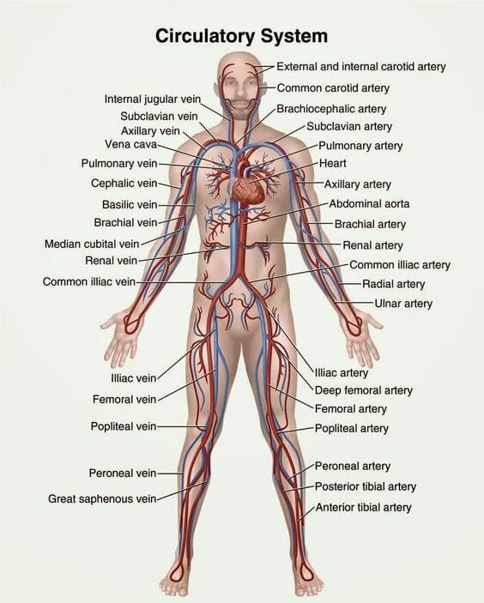

BLOOD
Blood is a fluid connective tissue which flows in blood vessels
- It has cells of various kinds called RBCs , WBCs and platelets.
- The fluid part of the blood is called plasma .
- RBC (Red blood cells)- contain a red pigment called haemoglobin
- Heamoglobin bind with oxygen and transport it to all the parts of the body
- The presence of heamoglobin makes blood appear red.
- WBCs (White blood cells ) fight against germs that may enter our body.
- Platelets helps in the clotting of blood.

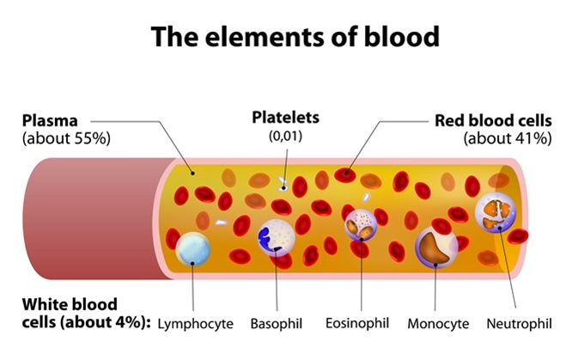

FUNCTION OF BLOOD
- It transports substance like digested food from the small intestine to the other parts of the body
- It carries oxygen from the lungs to the cells of the body
- It also transports waste for removal from the body .

BLOOD CIRCULATORY SYSTEM
It comparises of heart and blood vessels ( arteries , veins and capillaries )

- Arteries -It carries oxygen rich blood from the heart to all parts of the body
- Veins - Veins are the vessels which carry carbon – di – oxide rich blood from all the parts of the body back to heart
- Capillaries – Arteries divide into smaller vessels ,i.e arterioles . On reaching the tissues , they divide further into extremely thin tubes called capillaries .
The capillaries join up to form vennules and further joins to form veins which empty into the heart

PULSE
The throbbing sound due to the blood flowing in the arteries is called pulse
PULSE RATE
The number of beats per minute is called the pulse rate
A resting person , usually has a pulse rate between 72 and 80 beats per minute

HEART
The heart is a muscular organ which beats continuously to act as a pump for the transport of blood
The heart is located in the chest cavity with the lower tip slighty tilted towards the left
The heart has four chambers. The two upper chambers are called the atria (singular atrium ) and two lower chambers are called the ventricles. The partithion between the chambers helps to avoid mixing of blood rich in oxygen with the blood rich in carbon dioxide.
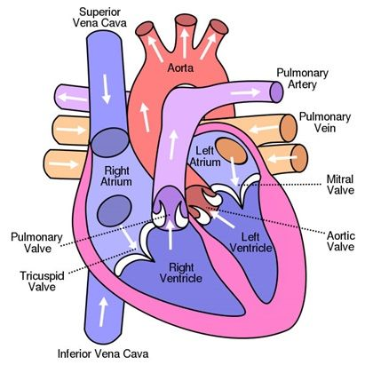

BLOOD FLOW

The heart has separate chambers to prevent oxygenated and deoxygenated blood from mixing. The auricles collect the blood and the ventricles distribute the blood . The deoxygenated blood needs to go to the lungs for oxygenation. The right auricle contracts and pour the impure blood to the relaxed right ventricle below it.
Then the right ventricle ventricle contracts and sends the deoxygenated blood to the lungs through the pulmonary arteries for oxygenation. The oxygenated blood from the lungs comes back to the heart which then pumped to the rest of the body. The oxygenated blood enters the left auricle through pulmonary veins , then the left auricle contracts and pumps the oxygenated blood to the left ventricle.
The left ventricle contracts and sends the oxygenated blood to the rest of the body through aorta . The valve prevents the back flow of blood .

HEARTBEAT
The walls of the chambers of the heart are made up of muscles . These muscles contract and relax rhythmically. This rhythmic contraction followed by its relaxation constitute a heartbeat.
The doctor feels our heartbeats with the help of an instrument called stethoscope.
