CHAPTER 10 REACHING THE AGE OF ADOLESCENCE
CLASS VIII HAND OUT
MODULE 4

HORMONES OTHER THAN SEX HORMONES
- Apart from the pituitary , the testes and ovaries , there are other endocrine glands in the body such as thyroid, pancreas and adrenals etc. *Thyroid gland produces thyroxine which prevents‘goitre.
- Endocrine part of Pancreas secretes insulin.
- A person was suffering from ‘ diabetes’ because his pancreas was not producing the hormone insulin in sufficient quantities.
- Adrenal glands secrete hormones which maintain the correct salt balance in the blood.
- Adrenal also produce the hormone adrenalin. It helps the body to adjust to stress when one is very angry, embarrassed or worried.

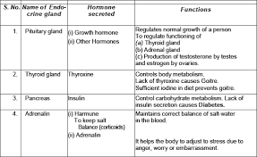

*Thyroid and adrenal secrete their hormones when they receive orders from the pituitary through its hormones.
* Pituitary also secretes growth hormone which is necessary for the normal growth of a person.

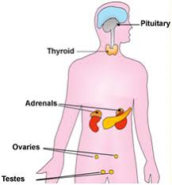

Fig : Position of endocrine glands in the human body

ROLE OF HORMONES IN COMPLETING THE LIFE HISTORY OF
INSECTS AND FROGS
METAMORPHOSIS- The change from larva to adult is called metamorphosis.
- In insects , metamorphosis is controlled by insect hormones.
- In a frog , it is controlled by thyroxin, the hormone produced by thyroid.
- Thyroxine production requires the presence of iodine in water.
- If the water in the which the tadpoles are growing does not contain sufficient iodine , the tadpoles cannot become adult.

PREPARED BY
A K MISHRA
TGT/SS
AECS-3, MUMBAI

