CHAPTER 10 REACHING THE AGE OF ADOLESCENCE
CLASS VIII HAND OUT MODULE 1
ADOLESCENCE AND PUBERTY
- The period of life , when the body undergoes changes, leading to reproductive maturity, is called adolescence.
- Adolescence begins around the age of 11 and lasts upto
18 or 19 years of age.
- Since this period covers the ‘teen’ (13 to 18 or 19 years of age) , adolescents are also called ‘teenagers’.
- In girls , adolescence may begin a year or two earlier than in boys.
- The period of adolescence varies from person to person.
- The human body undergoes several changes during
Adolescence.
- These changes mark the onset of puberty.
- The most important change which marks puberty is that
boys and girls become capable of reproduction.
- Puberty ends when an adolescent reaches reproductive maturity.

CHANGES AT PUBERTY
- Increase in height- The most conspicuous change during puberty is the sudden increase in height.
- At this time the long bones ,that is , the bones of the arms
and the legs elongate and make a person tall.
- Initially , girls grow faster than boys but by about 18 years
of age , both reach their maximum height.
- The rate of growth in height varies in different individuals.
- Some may grow suddenly at puberty and then slow down, while others may grow gradually.
- All parts of the body do not grow at the same rate.
- Sometimes the arms and legs or hands and feet of adolescents look oversized and out of proportion with the body.
- But soon the other parts catch up and result in a proportionate body.
- This is because height depends on the genes inherited from parents.
- It is , however, very important to eat the right kind of food during these growing years.
- This helps the bones, muscles and other parts of the body get adequate nourishment for growth.
CHANGE IN BODY SHAPE
- This is because they have entered the age of puberty
when shoulders generally broaden as a result of
growth.
- In girls, the region below the waist becomes wider.
- In boys, the muscles of the body grow more prominently
than in the girls.
- Thus, changes occurring in adolescent boys and girls are
different.

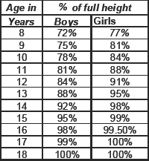

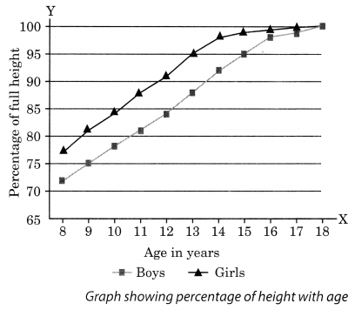
PREPARED BY
A K MISHRA
TGT/SS
AECS-3, MUMBAI

