Atomic Energy Education Society – Distance Learning Programme
Class – VIII Subject – Mathematics
Chapter – 7: CUBES AND CUBE ROOTS

Hand-out (Module 1/3)

Introduction
There is an interesting story about Srinivasa Ramanujan, India’s great mathematical genius and his famous mathematician friend Prof. G H Hardy. One day Prof. Hardy visited Ramanujan in a taxi whose number was 1729. Hardy described 1729 as a dull number to Ramanujan. To this, the great Ramanujan quickly interjected and said that 1729 is the smallest number that can be expressed as a sum of two cubes in two different ways. Indeed an interesting number.
Hardy – Ramanujan Number
According to Ramanujan, the number 1729 is the smallest number that can be expressed as a sum of two cubes in two different ways:
1729 = 1728 + 1 = 12 ³ + 1 ³
1729 = 1000 + 729 = 10 ³ + 9 ³
1729 has since been known as the Hardy – Ramanujan Number.
1729 is the smallest Hardy– Ramanujan Number.
There are an infinitely many such numbers, such as …
4104 = 2 ³ + 16 ³ and 4104 = 9 ³ + 15 ³
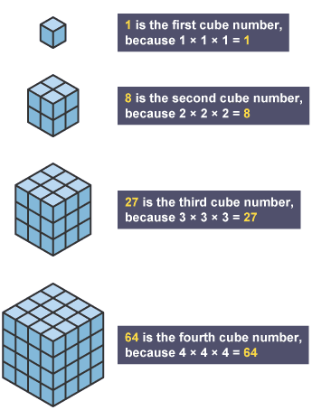
13832 = 18 ³ + 20 ³ and 13832 = 2 ³ + 24 ³
Cubes
The word ‘cube’ is used in geometry.
A cube is a solid figure which has all its sides equal.
8 cubes of side 1 cm will make a cube of side 2 cm.
27 cubes of side 1 cm will make a cube of side 3 cm.
64 cubes of side 1 cm will make a cube of side 4 cm.

The numbers 1, 8, 27, 64 … are called perfect cubes or cube numbers.
A perfect cube or a cube number is obtained when a number is multiplied by taking it three times.
1 x 1 x 1 = 1 ³ = 1
2 x 2 x 2 = 2 ³ = 8
There are only ten perfect cubes from 1 to 1000.
3 x 3 x 3 = 3 ³ = 27
4 x 4 x 4 = 4 ³ = 64
5 x 5 x 5 = 5 ³ = 125
6 x 6 x 6 = 6 ³ = 216
7 x 7 x 7 = 7 ³ = 343
8 x 8 x 8 = 8 ³ = 512
9 x 9 x 9 = 9 ³ = 729
10 x 10 x 10 = 10 ³ = 1000
Some properties of cube numbers/perfect cubes
- Cubes of even numbers are always even.
Example: 2 ³ = 8
4 ³ = 64
6 ³ = 216,
12 ³ = 1728 etc.
- Cubes of odd numbers are always odd.
Example: 1 ³ = 1
3 ³ = 27
5 ³ = 125
11 ³ = 1331 etc.
- The cube of a negative number is always negative.
Example: (– 3)³ = (– 27)
(– 9)³ = (–729)
(– 14)³ = (– 2744)
- (a) If the one’s digit of a number is 1, then the one’s digit of its cube is
also 1.
Example: 11 ³ = 1331
(b) If the one’s digit of a number is 2, then the one’s digit of its cube is 8.
Example: 12 ³ = 1728

(c) If the one’s digit of a number is 3, then the one’s digit of its cube is 7.
Example: 23 ³ = 12167
(d) If the one’s digit of a number is 4, then the one’s digit of its cube is
also 4.
Example: 14 ³ = 2744

(e) If the one’s digit of a number is 5, then the one’s digit of its cube is
also 5.
Example: 25 ³ = 15625
(f) If the one’s digit of a number is 6, then the one’s digit of its cube is
also 6.
Example: 16 ³ = 4096

(g) If the one’s digit of a number is 7, then the one’s digit of its cube is 3.
Example: 17 ³ = 4913
(h) If the one’s digit of a number is 8, then the one’s digit of its cube is 2.
Example: 18 ³ = 5832
(i) If the one’s digit of a number is 9, then the one’s digit of its cube is
also 9.
Example: 19 ³ = 6859

- The number of zeroes at the end of a perfect cube is always a multiple of 3.
So the number of zeroes at the end of a perfect cube can be 3, 6, 9, 12 ….
Example: 1000, 8000, 27000000, 1728000, 64000000000 etc. are all perfect cubes.

^*^*^*^*^*^*^*^*^*

