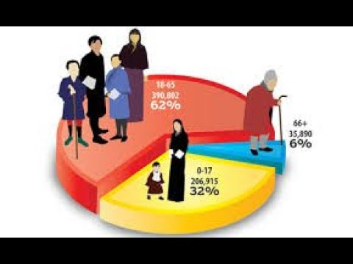
- Population composition growth (Ref. Module- 3/3_Slide 2/10)

- Uses of population Composition (Ref. Module- 3/3_Slide 3/10)
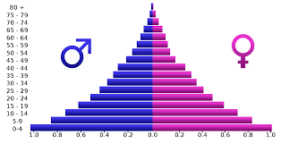
- Population Pyramid: Meaning, uses(Ref. Module- 3/3_Slide 4/10)
- Indication by the shape of population pyramid(Ref. Module- 3/3_Slide 5/10)
- Population pyramid of Kenya (Ref. Module- 3/3_Slide 6/10)
- Population pyramid of India (Ref. Module- 3/3_Slide 7/10)
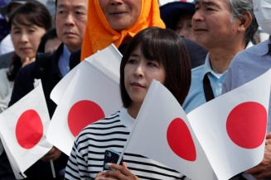
- Population pyramid of Japan (Ref. Module- 3/3_Slide 8/10)

- Human Resources: Future of nation(Ref. Module- 3/3_Slide 9/10)

