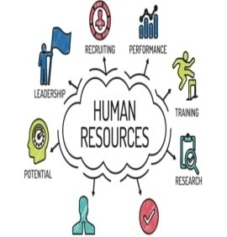
- What is Human Resource? (Ref. Module- 1/3_Slide 2/14)
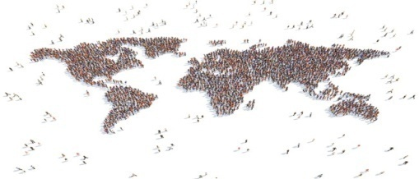

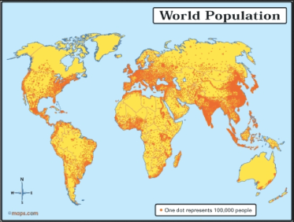
- Human resources like other resources are not equally distributed over the world. (Ref. Module- 1/3_Slide 3/14)

- Distribution of population. (Ref. Module- 1/3_Slide 4/14)

- Some areas are very crowded and some are sparely populated. (Ref. Module- 1/3_Slide 5/14)
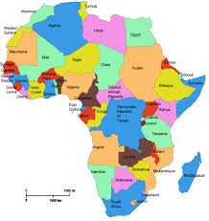
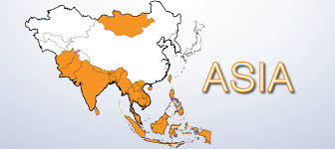
- Almost three-quarters of the world’s people live in two continents Asia and Africa. (Ref. Module- 1/3_Slide 6/14)

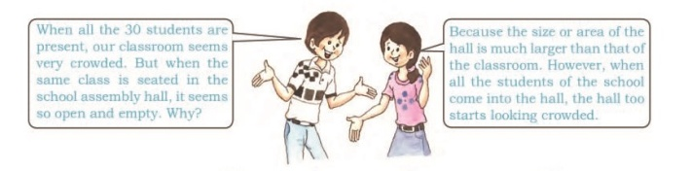
- Sixty per cent of the world’s people stay in just 10 countries. All of them have more than a 100 million people. (Ref. Module- 1/3_Slide 7/14)

- Density of population (Ref. Module- 1/3_Slide 8/14)
- Factors affecting distribution of population. (Ref. Module- 1/3_Slide 9/14)
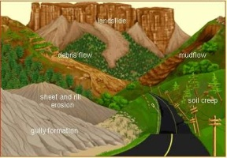
- Geographical Factors : Topography (Ref. Module- 1/3_Slide 10/14)
- Geographical Factors : Climate and Soil (Ref. Module- 1/3_Slide 11/14)
- Geographical Factors : Water and Mineral (Ref. Module- 1/3_Slide 12/14)

- Social, Cultural and Economic Factors (Ref. Module- 1/3_Slide 13/14)

