HANDOUT
EXTEMPORE
Having already discussed on the importance of honing writing skill, in this section lets delve on the need to enhance our speaking skill. In fact, we are aware that mostly we communicate through speaking. Hence, the significance of developing this skill is very essential.
Here we are going to look into what is Extempore, its role in language communication, some ideas to deliver a good extempore and the advantages of mastering it.
1.What is Extempore?
Extempore is a speech that is:
- Extempore is a stage performance which is carried out without preparation of any kind.
given on the spot
- The other commonly used names for extempore are impromptu speaking, improvised speaking and extemporaneous speaking
- Tests ones knowledge on the given topic
- Ability to use apt vocabulary
- Frame meaningful sentences within the limited time
- Ability to think, organise and speak confidently
- Ability to come out with quick logical sequencing of the ideas
2. Conducting extempore
- Students are required to pick any card and speak for a couple of minutes on the topic written on it. The topics may be repeated.
- The performance will be evaluated in terms of specific standards set, including the clarity and completeness of the speech and the quality of presentation in explaining the topic, as
3. Structuring your speech with ‘2Ts’
- ‘T’ elling the audience what you are going to tell them
- “T”elling within the time frame of two or three minutes.

4.Rubrics
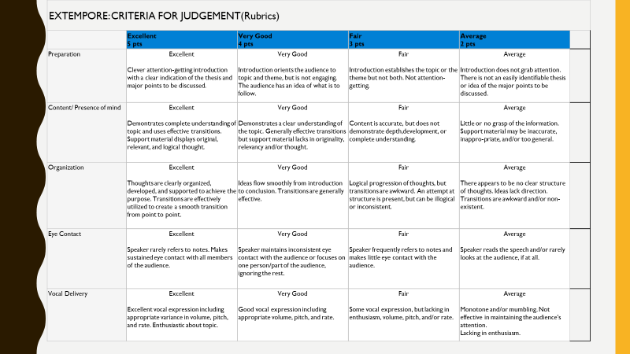

Mind Mapping
- A mind map is a tool for the brain that captures the thinking that goes on inside your head. Mind mapping helps you think, collect knowledge, remember and create ideas. Most likely it will make you a better thinker.
- Mind maps can be created in many different ways, but they share the same basics:
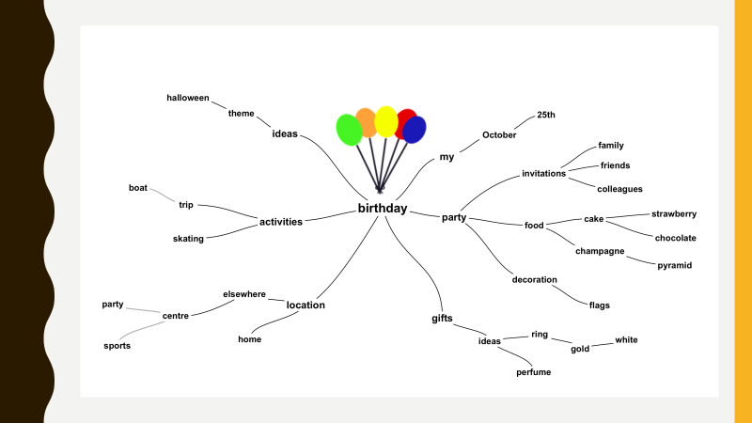

Central theme
- A central theme is placed in the centre of a blank page. This is the title, the subject, a problem or just a thought. When thinking of something images automatically take form in your head. For example the image of a “colorful bunch of balloons” when thinking of “birthday”
Associations
- From the central theme associations radiate out. Associations directly from the central theme are called first level associations. Then second level associations are created, third level and so on. The brain thinks by imagination and association. When associations are created, connections are made. These connections are essential for remembering and thinking.
6. Merits
- Improves ones fluency in speaking.
- Enhances vocabulary and Confidence .
7. Tips for giving a good extempore
- Prepare ahead of time by reading a lot about current events.
- Stick to the topic.
- Mind Mapping
- Have an opening paragraph.
- Try to have something pithy as your first line to get the attention of audience.
- Conclude by summarizing the topic.
- Importance of Extempore speaking
- Confidence is the key to help you develop this method of communication to a large audience.
8. Watchdogs for perfection
- One of the biggest mistakes speakers make is trying to say too much. A speech is a golden opportunity, so you want to say all you can. Limit your speech to your knowledge – many people tend to talk a little more without having any prior information
- The problem is, the more points you make, the less likely the audience is to remember what you say.
- Do not memorize – memorizing information only leads to it being stiff and less conversational
- It’s much better to limit yourself to four points and hammer them home.
- Ideally, the first two or three points should add up to your last point.
- Focus on opening and closing statements – the opening and closing statements decide on how the audience welcomes your speech

9. Example for Extempore
Red or Blue?
- The colors red and blue remind me of the corporate cola giants- Coke and Pepsi; while Coke has a dominant splash of red in its promotional campaigns, Pepsi connects with its customers through a brilliance of blue. Taking this corporate warfare ahead is the example of Jet Airways (blue) and Kingfisher (red), where the latter was a strong challenger to the long drawn supremacy of Jet Airways in the private aviation sector.
- Furthermore, it reminds me of this wonderful book authored by John Gray, "Men are from Mars, Women are from Venus", where men and women are two diametrically opposite species in terms of their sensitivity levels, behavioral patterns and temperamental differences.
- However, looking at the topic from another angle is the coexistence of red and blue in the "VIBGYOR" spectrum to make white light, which is the essence of life....

THANK YOU

